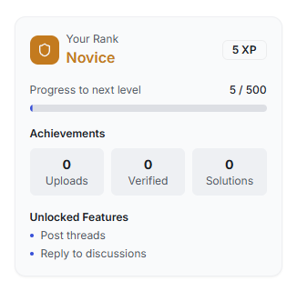

**we have to add , a article with link , oping new page showing how user can level up and also i**mporve the UI make the ui compact , more informative professional , simple, any thing relvevant ,

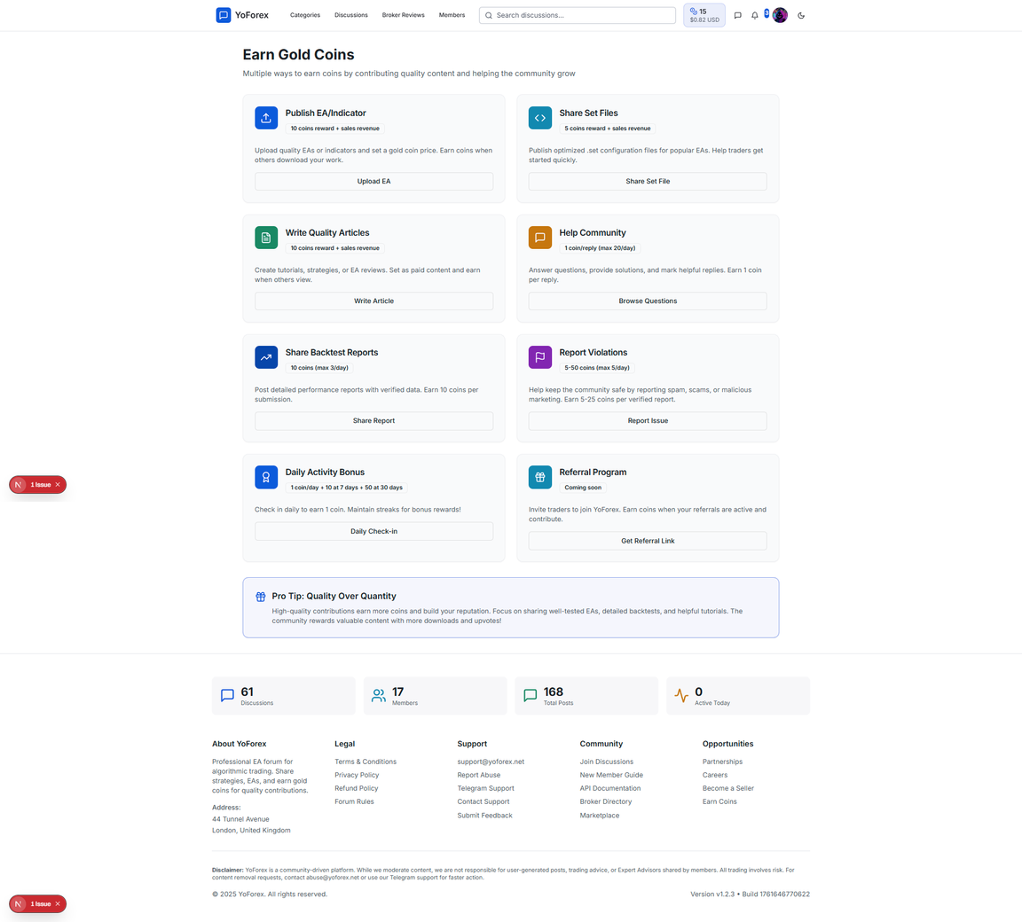

we have to improve the UI and made it user friednly and easy to understand and simple understandble , instead of giving buttons add links of articles that how user can earn explain them if you want you can create images for that articles too and link them and make sure you route properly and if you want you can share the links



same 404 errors on every links



when clicking showing category not found

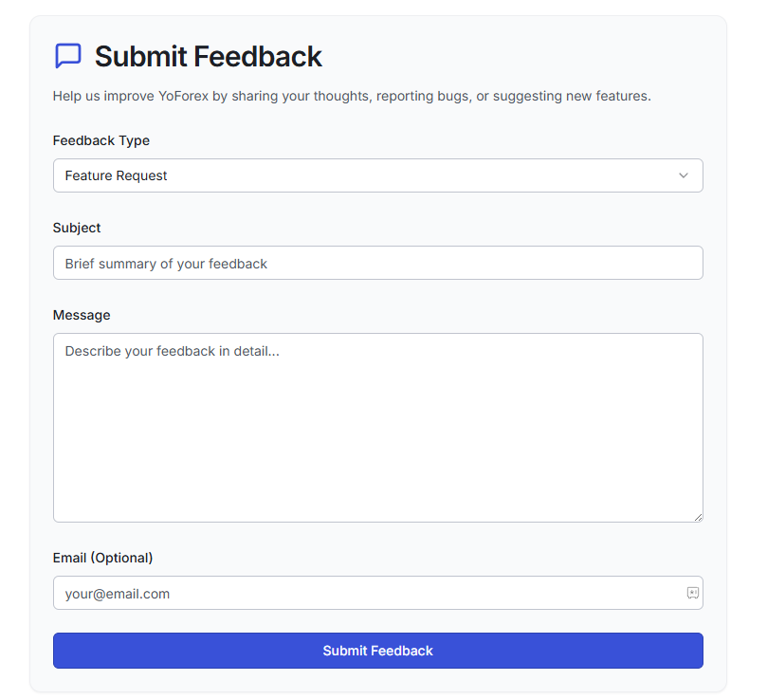

submitting feed back shows nothing



clicking not working

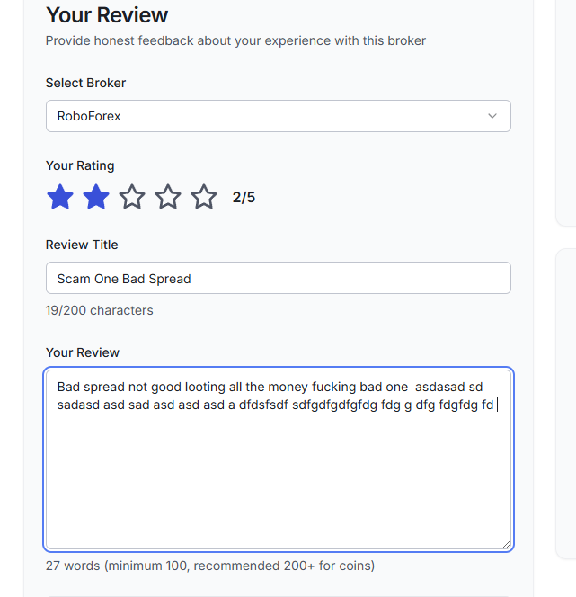

the count in words but i want in per word count when i put space then it counting as a word please check  

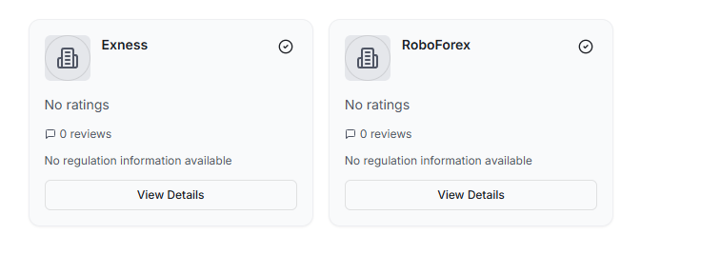

can you create a api or something like that it should fetch the logo of this broker automatically and place it here and when user type to add the broker , after 2 or 3 words of typing he should get the suggestions i dont knwo can you add it  

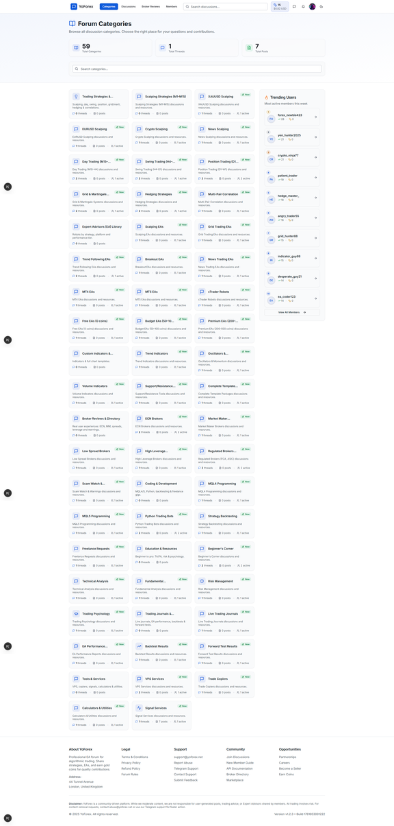

**imporove the catrgory page good desgin and user experience think harder to refine it add backend apis routing and search filter and some other things the side bars are looking empty add new features with full funtioalites**

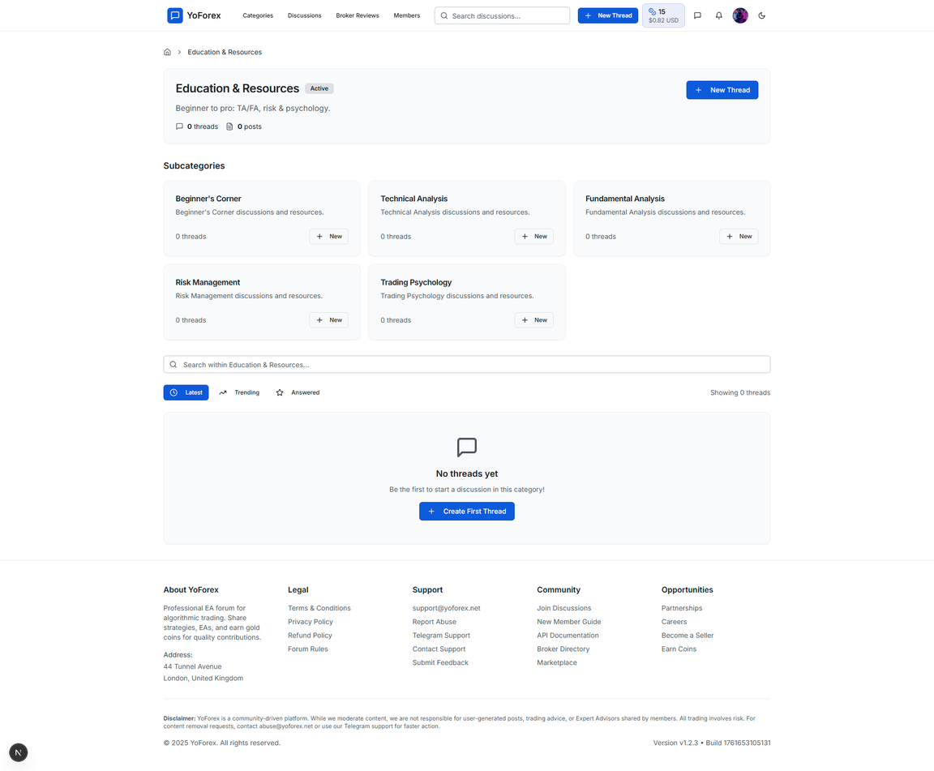

in these types of page add new features make the ui more good and user friendly keep it simple , but professional , with full funcnalities think harder this is not the only page the side bars are looking empty

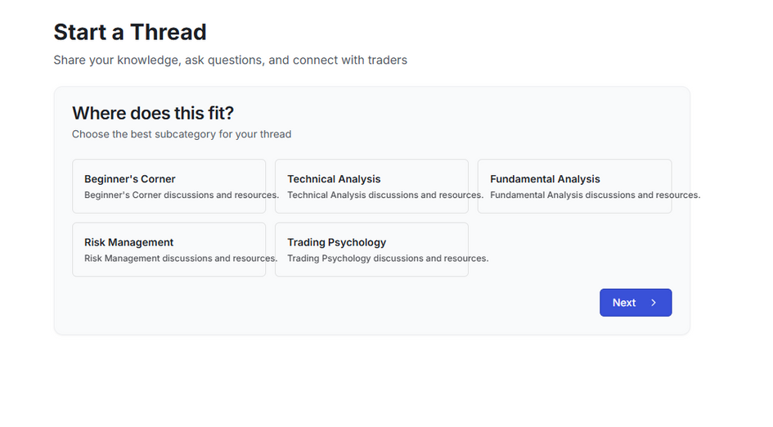

make the ui more good for this page , look the texts are over flowing from the boxes or cards , the side bars are still empty in these types of page add new features make the ui more good and user friendly keep it simple , but professional , with full funcnalities think harder this is not the only page the side bars are looking empty

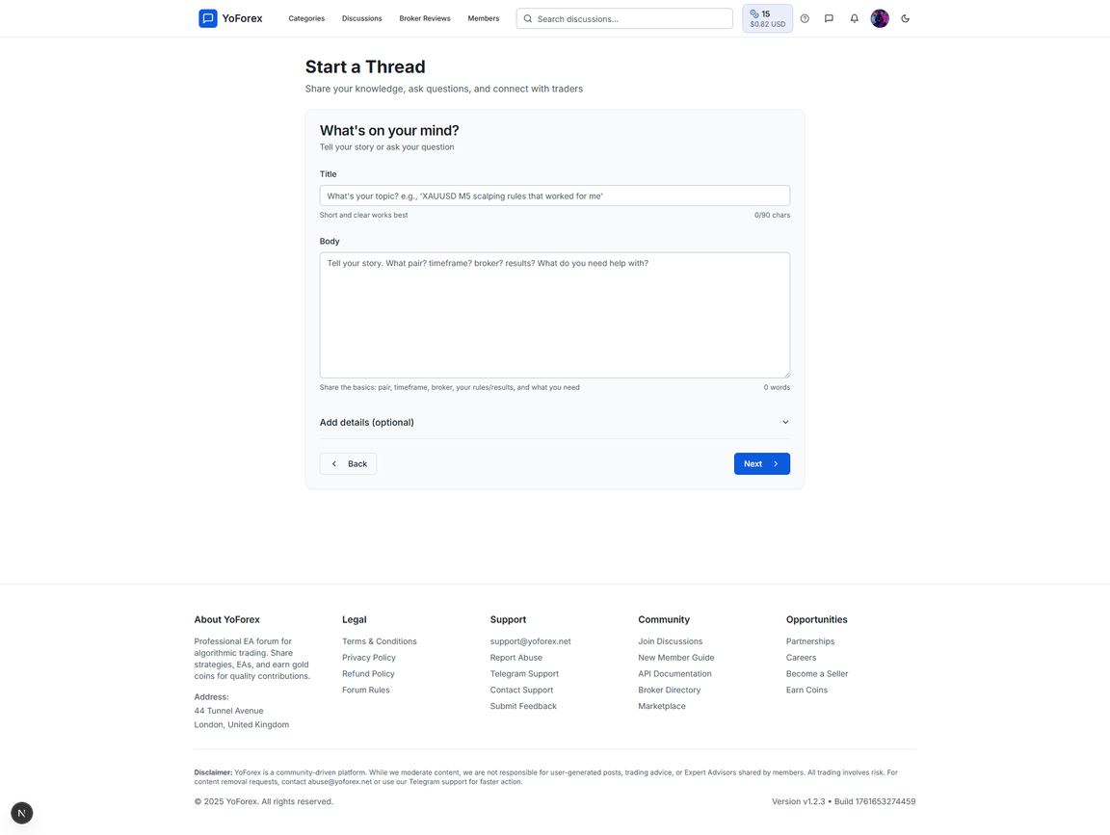

think about it , abut creating a thread , related to the niche or categoies give more options with proper seo , seo should be backend things auto handel but the user should go it and do it in a natural way , stilll the side bars are empty in these types of page add new features make the ui more good and user friendly keep it simple , but professional , with full funcnalities think harder this is not the only page the side bars are looking empty

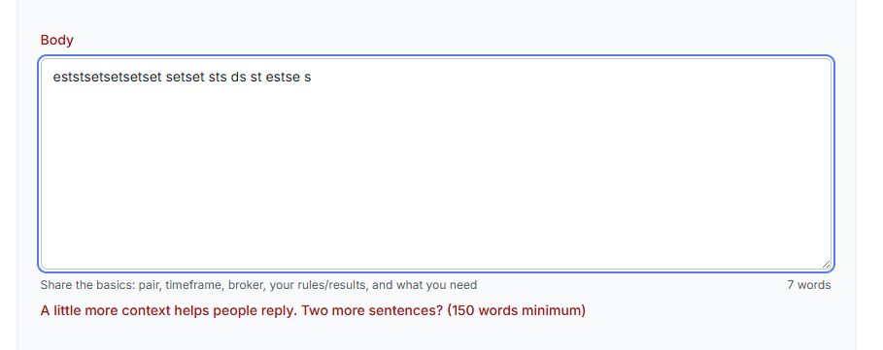

look for the word count errors check every thing deeply i show you only one example but there are many you have to fin it and fix them all

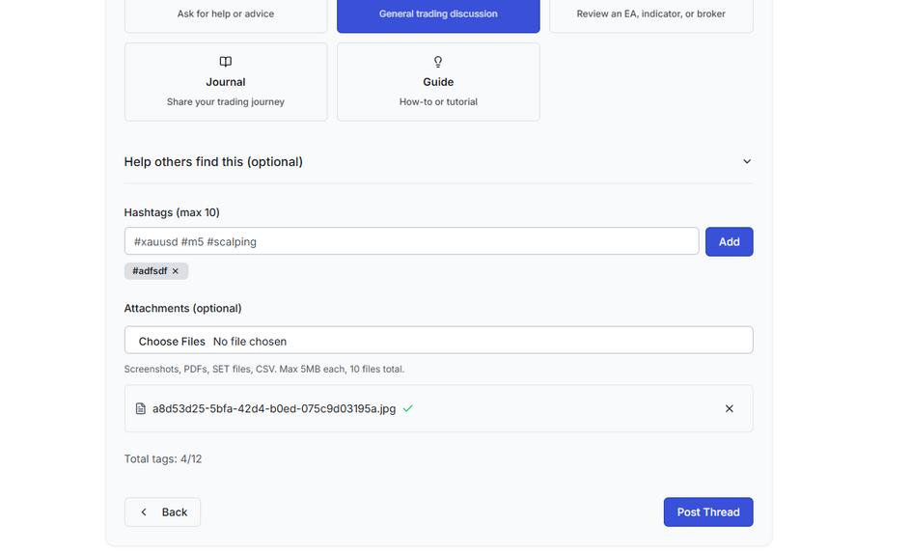

posting thread not working

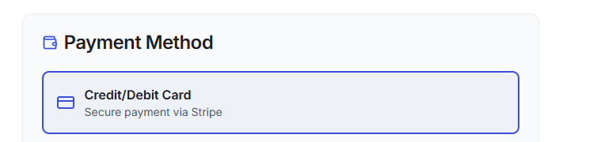

remove credit debit card we will only have crypto currency

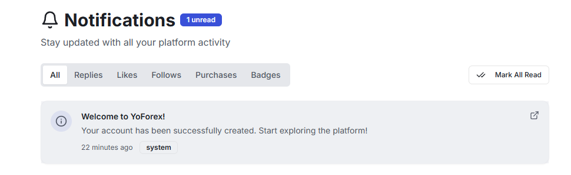

notification api not working , when click unread its not working

Next thing Keep in Mind Creating a thread in for discusstion , and creating or sharing programs like ex4, ex5 , pine scripts are difreent so both the post things are diffrent think harder take a approach for it  

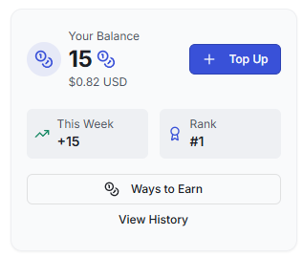

view history and ways to earn not working

impore ui also check the logic and maths for earn and api  

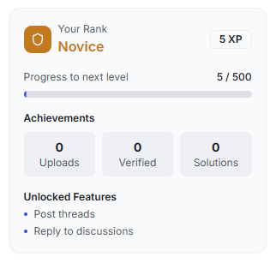

check logic , maths calcualtion for the rank and all things all things are related to it or not    
for every 5 mins of activity auto add 0.5 Coin , and recive notification and chck all the apis  

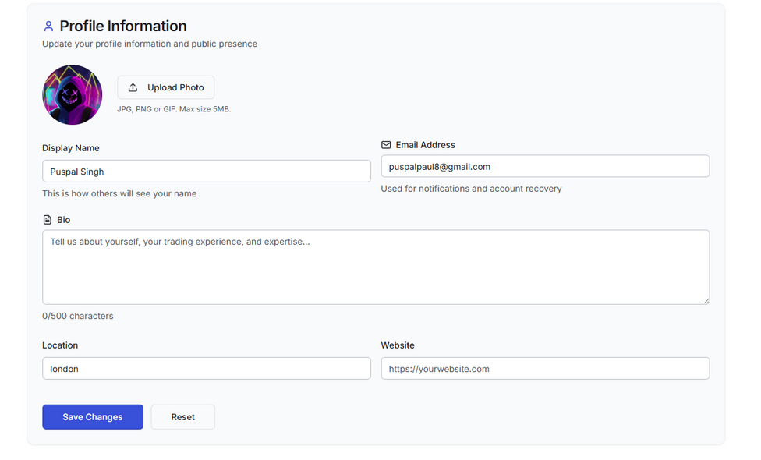

apis not working , i write but ifos not saved

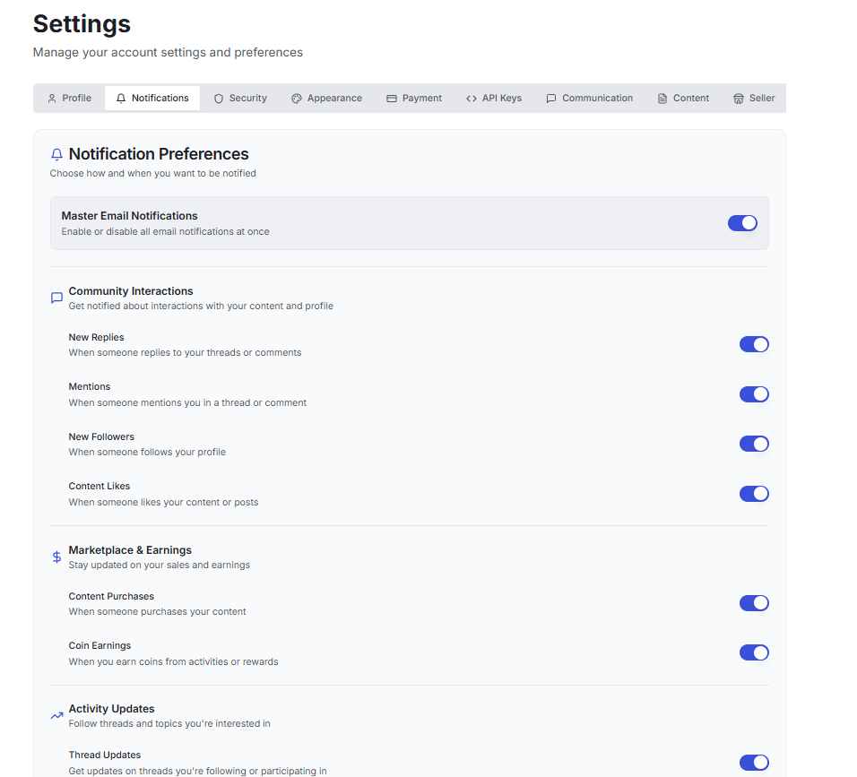

nothing workinking for notifications check full thing

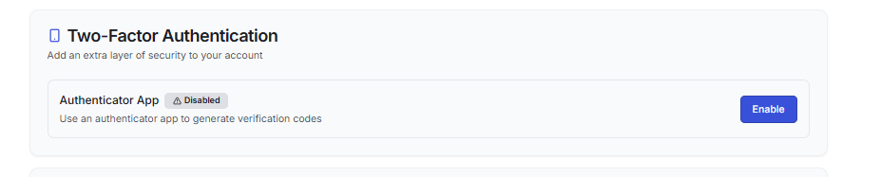

not working

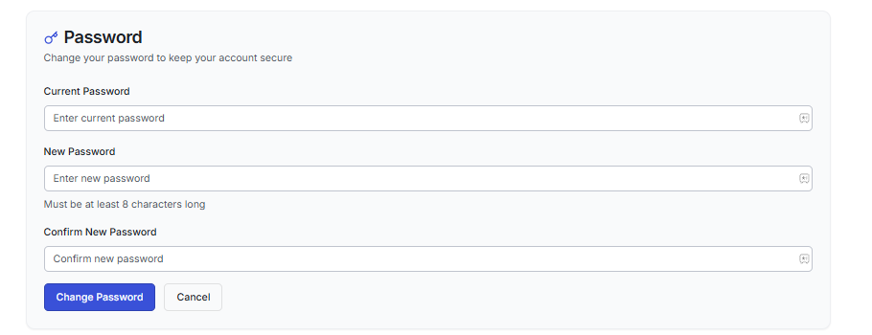

not working

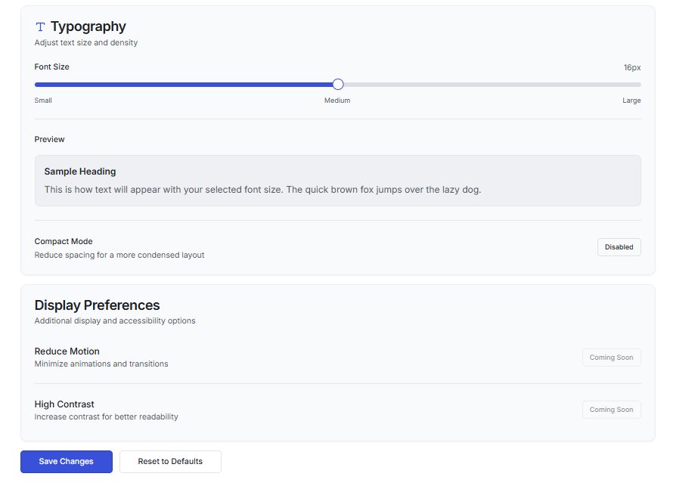

topography not working please set the apis this is crucial it must work

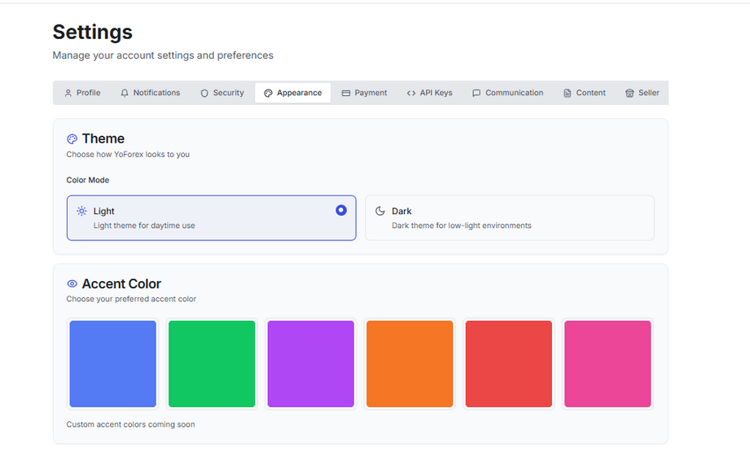

thmes also not working please check and do the needful

0c18862cf109a13ce2aed89056789113.png

craete a scroll bar or someting good to expore all menus